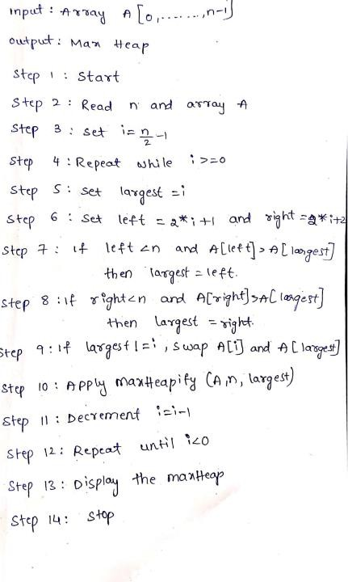
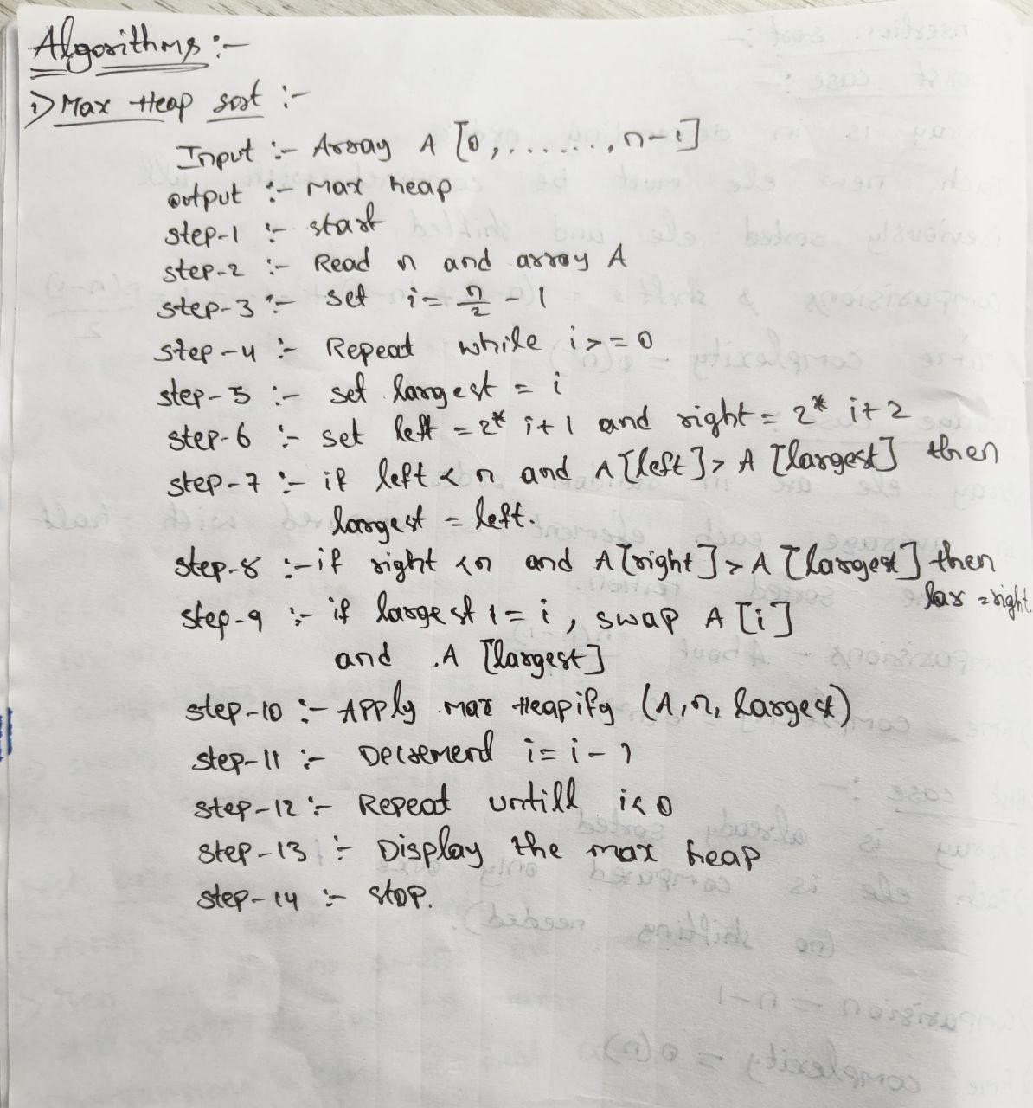


PRACTICAL-03

AIM: Implementation of max-heap sort algorithm

MAX-HEAP SORT ALGORITHM:

PROGRAM:
#include <iostream> using namespace std;

void MaxHeapify(int arr[], int size, int i) { int largest = i;
int l = 2 * i + 1; int r = 2 * i + 2;
if (l < size && arr[l] > arr[largest]) largest = l;
if (r < size && arr[r] > arr[largest]) largest = r;



if (largest != i) { swap(arr[i], arr[largest]);
MaxHeapify(arr, size, largest);
}
}
void HeapSort(int arr[], int size) { for (int i = size / 2 - 1; i >= 0; i--)
MaxHeapify(arr, size, i);
for (int i = size - 1; i >= 1; i--) {
swap(arr[0], arr[i]); MaxHeapify(arr, i, 0);
}
}
int main() { int size;
cout << "Enter number of elements: "; cin >> size;

int arr[size];
cout << "Enter " << size << " elements:\n"; for (int i = 0; i < size; i++) {
cin >> arr[i];
}
HeapSort(arr, size);

cout << "Sorted array: ";
for (int i = 0; i < size; i++) { cout << arr[i] << " ";
}
cout << endl;

return 0;
}

OUTPUT:
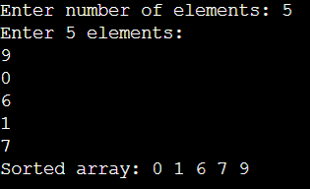

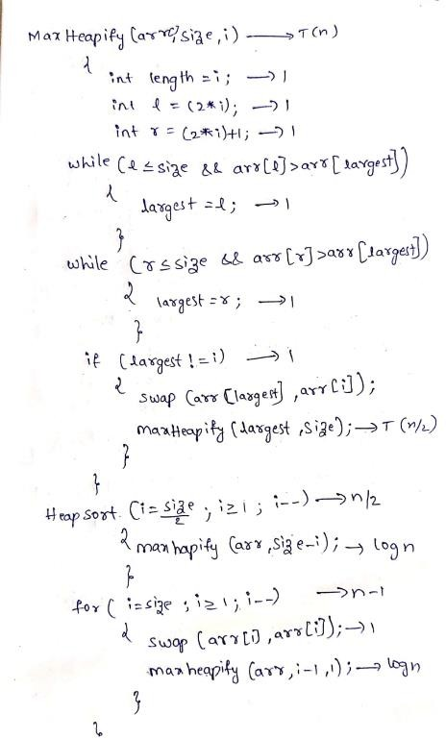
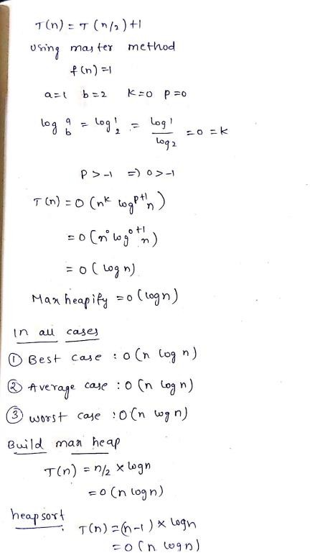
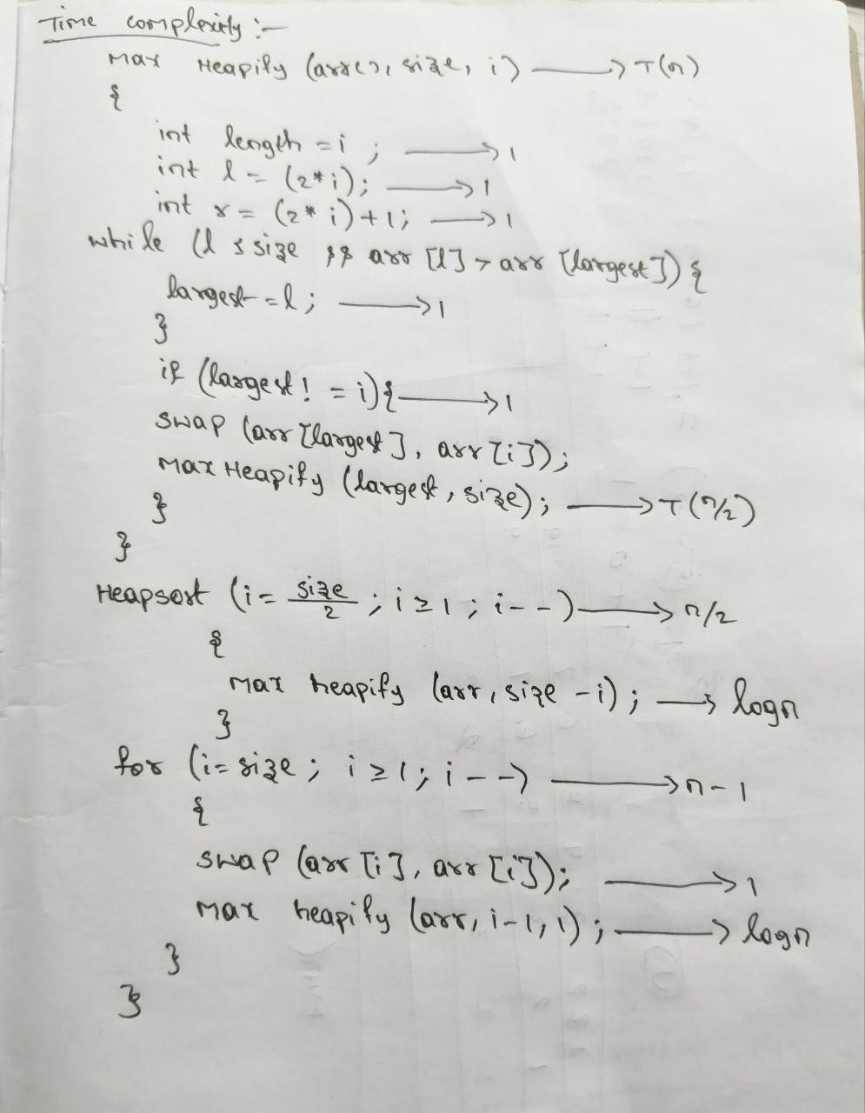
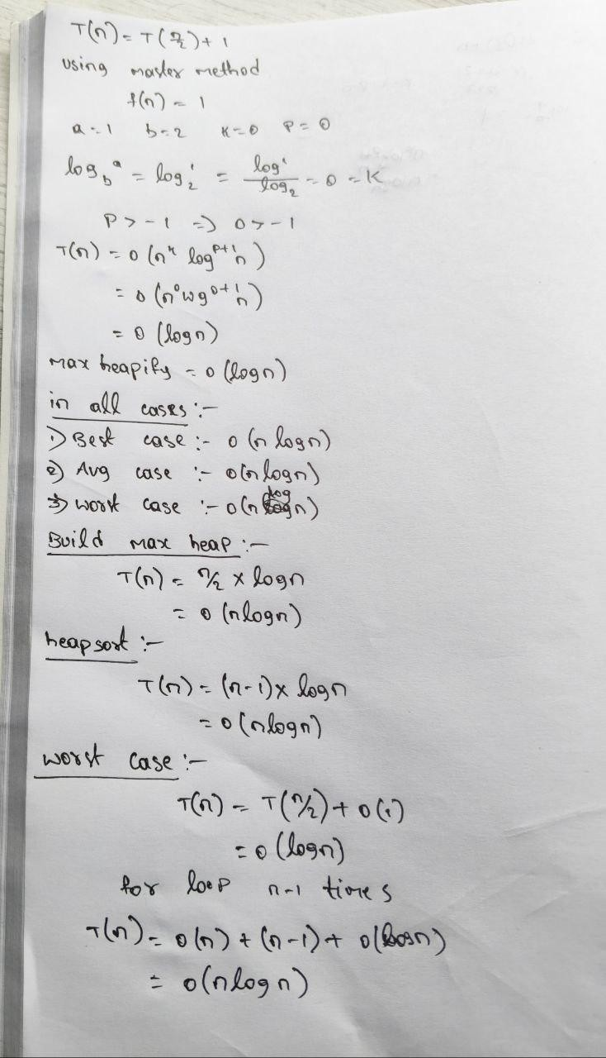


TIME COMPLEXITY:



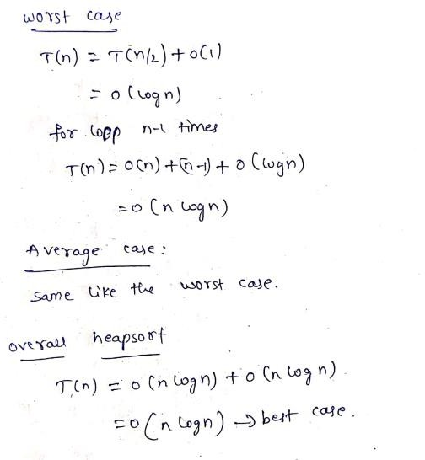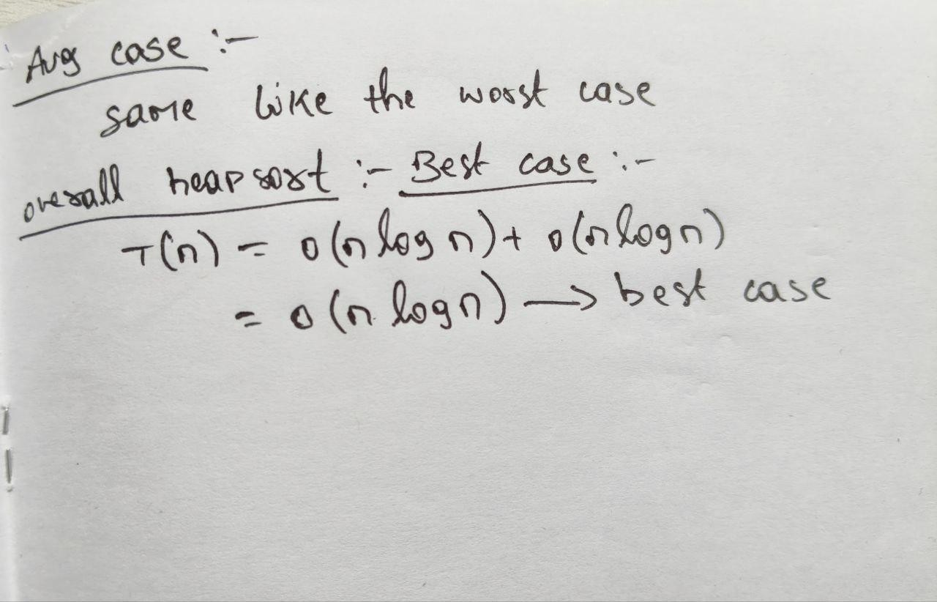

CONCLUSION:
The Max-Heap Sort algorithm was successfully implemented using the Max-Heapify method. The largest element is repeatedly placed at the end of the array, resulting in a sorted array in ascending order. The time complexity of Heap Sort is O(n log n).

